Nina Kenmogne

Python Strings homework:

9/19/24

Homework 1: Your task is to write a Python program that displays a custom banner using the # symbol and escape characters for formatting.

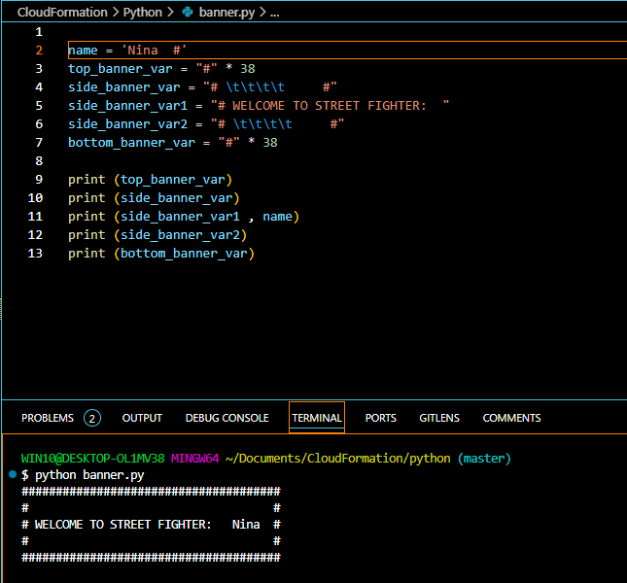

Lab1: Using format() method

Define 3 variables in your program, then using the format method, display a sentence in the following format

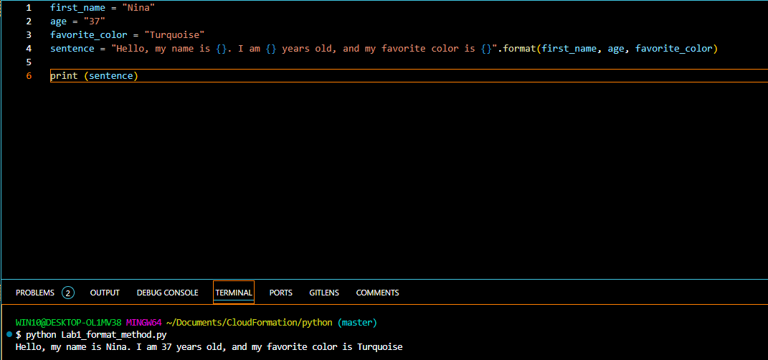

Lab 2: Define 2 variables containing a city as a string, a temperature as a floating point, then use the f-strings to display the sentence in the following format.

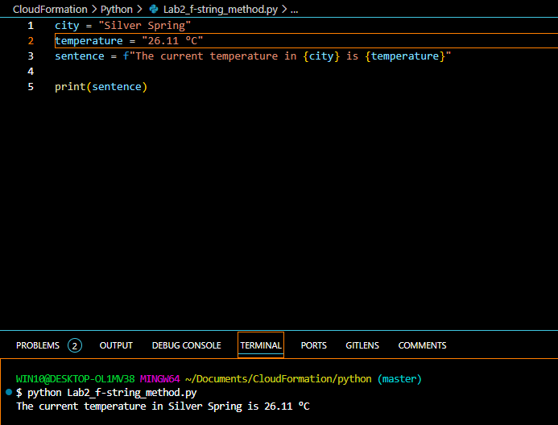

Link to my GitHub repo: https://github.com/Ninilove/Banner_project.git